Template – Job analysis


A job analysis is done before you advertise for a new employee. It allows you to work out exactly what the business needs and to identify ways in which an existing role could be adapted. After you’ve done a job analysis for a position, it will be easier to fill in the job description template.

GENERAL DETAILS

Date of review

Reviewed by

Job title

Department

Award/Agreement

Classification/Level/Grade

Reports to

Supervision of

DUTIES AND RESPONSIBILITIES

Duties and | Major functions | Selection criteria, competencies | Qualifications | Essential or
responsibilities |  | and experience | required | desirable? (write
 |  |  |  | an E or D in this
 |  |  |  | column)
Serving customers | Customer service | At least one year’s retail experience | Certificate | E
 |  |  | II in Retail
 |  |  | Operations
Accepting payment | Managing cash |  |  | E
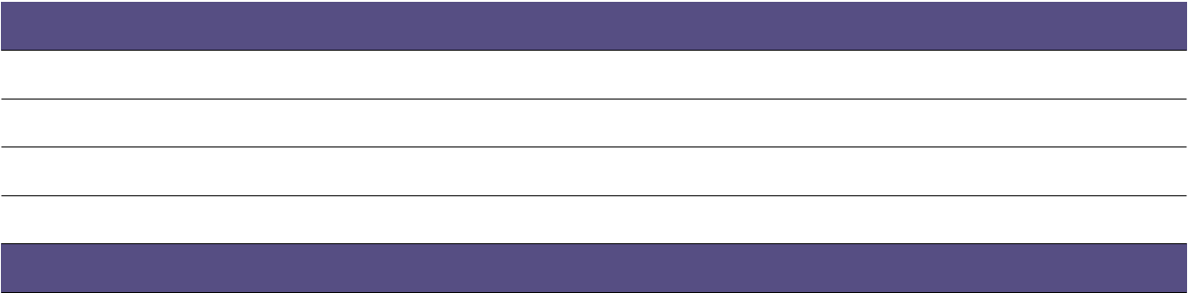

GENERAL OVERVIEW OF THE JOB

VALIDATION AND FUTURE REVIEW

Validated by staff member

Next job review date

